Issue 8. May 8 2008.


‘EPIC SQUASH’
Marston and Durkin lauded for Titanic Battle. Is it time that some challengers stepped up to the plate? Squash News brings you the latest…..

Fans (most of which were hot ladies, wearing sexy lingerie), were treated to an exhibition of what some said was ‘Fantasy Squash from Outer Space’ at last night’s ‘Havana Club Trophy’. Both Marston and Durkin were in scintillating form, with both men literally sweating and bleeding for the cause.
In his post-match comments, John Motson, who was missing the UEFA Cup Semi-Final, due to the superior importance of the ‘Havana Club Trophy’ stated that ‘Some of the cross-court volleys that these men pulled out of the bag this evening were remarkable. There is no way that any player in the world could get close to the performances that they put in this evening’.
Indeed, Durkin was flying about the hallowed Court 4 like a super-hero, making some returns that defied the laws of physics.
Both players had to be escorted from the West Totton Astra Dome by heavily armed security at the end of the evening, due to the amount of supermodels trying to accost them. ‘I feared for my life’ exclaimed Marston, ‘They were like a pack of hungry wolves!’

Squash news honey of the week: My future wife, Evangeline Lilly.
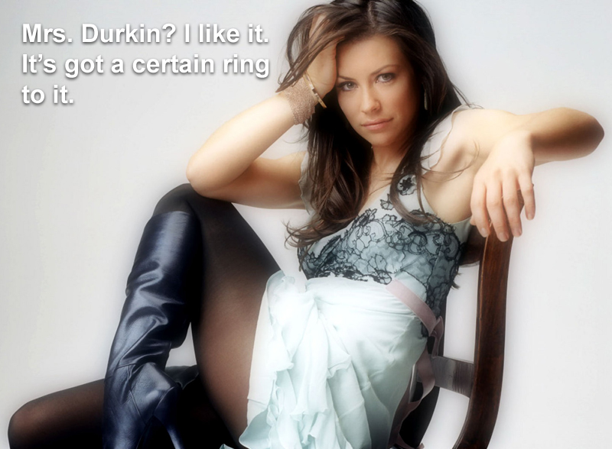

Lack of commitment: ‘Sickening’. Alex speaks out:
Usually the reserved man of the Astra Dome, this week, the spokesman for Squash News: Alex, otherwise known as ‘the bloke at reception’ has hit out at ‘the missing trio’ saying their lack of commitment on a Thursday evening has ‘Sickened him’.
In a rare interview with Squash News, he bemoaned the cancellation of another court booking and said that it made him wonder whether Marston and Durkin were the only players ‘fit to tread the sacred boards of The Astra Dome’.
‘Every week there’s some excuse’ he told us, ‘Playing here at the Astra Dome is a privilege, not a right – the lack of revenue has had a real knock-on effect on my family’.
Durkin Senior, Buckley and Pollinger have all slipped further down the world rankings this week, however special dispensation has been given to Danny P, due to the long period of recovery needed to recover from his ‘Horror Injury’.

Pollinger to make long-awaited return next week?:
Dan Pollinger is likely to defy the Doctors who said that he’d ‘Never play again’, by taking to the courts for the first time in 3 weeks, at next week’s ‘Jeff Stelling Clash of Champions’.
Speaking to ‘Squash News’, Pollinger said that ‘Each day, the injury is getting better. It’s been frustrating to have to sit on the sidelines, but I should be back next week’. Question marks, however, have been raised over the Browning man’s lack of match-fitness, with both Marston and Durkin vowing to ‘Respect his timely comeback, but ultimately take him to the cleaners’. It looks like next Thursday is going to be a night packed full of headlines.

Durkin Senior to be reprimanded by World Governing Body:
Photographs in most of the tabloids last weekend, showed an inebriated Rich Durks, in a variety of Spanish drinking establishments, cavorting with local hookers and speaking to known crime figures in the Palma underworld.
The sorry pictures come, several weeks into what’s been a frustrating injury layoff and the lack of squash seems to be taking its toll on the veteran.
‘I miss the game terribly’ he was quoted as saying in Spanish Magazine ‘Scorchio Squashias’. ‘My life has no direction without The Astra Dome’.
Durkin will appear before the Astra Dome’s own disciplinary panel, before then going on to appear in front the World Governing Body, sometime in the next fortnight. ‘I hope we see the Rich Durks of old’ stated No.1 fan, Cliff Richard, ‘Just as soon as all this has all settled down.’ Squash News will, of course, keep you posted.

Buckley Back in the UK. Is The Comeback Imminent?
Tommi Buckley flew back into the UK this week, to a rousing reception at London’s Heathrow Airport. Thousands of well-wishers turned out, in a bid to get the big man to reconsider his proposed early retirement from the game and register in time for the ‘Jeff Stelling Clash of Champions’ on May 8th.
An emotional Buckley told Squash News that he had been ‘overwhelmed’ by the support shown to him and that he was giving ‘careful consideration’ as to whether to pass himself as fit to compete in next week’s clash.
Buckley, who has been in a Sri Lankan clinic for victims of Squash Burnout for the past 2 weeks, looked fresh as he left Heathrow with partner Harry Wheeler and their adopted turtle, ‘Trevor’.

This week’s sponsor: Jeff Stelling from Soccer Saturday:
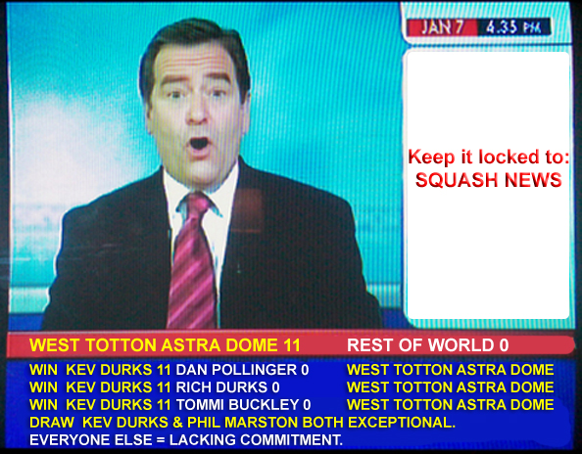

Keep it locked to Squash News. More insights from the Arena next week.

